**CAP 454: LINUX AND SHELL SCRIPTING - LABORATORY**

**CONTINUOUS ASSESSMENTS (C.A)-2**

**ST_NAME: - EKHLAKH AHMAD**

**REG NO.: - 12209166**

**ROLL NO.: - RD2215B67**

**SECTION: - D2215**

**GROUP: - 2**

**Q. How to change root Password?**

**Process: -**

* Open VMWare.
* Select RedHat Linux form left pane.
* Click on “power on this virtual machine”.
* Some Process are running.
* Then a dialog box open.
* Press Ctrl + G and then press e. (Quickly)
* Again, open a dialog box open.
* Select 2nd option with Arrow key and Press e.
* Again, then a dialog box will be open.
* After text “scsi” type space and 1.
* Then press Enter key.
* Again, dialog box will be open.
* Press b (for butting).
* New window will be open.
* Type “passwd” then enter key. Or,
* Type “passwd” space username.
* Press enter key.
* Type password as you need.
* ReEnter your password.
* Press Enter key.
* Password Updated successfully.

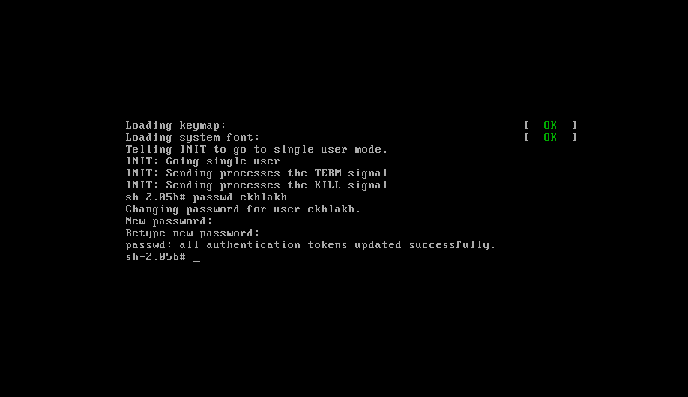

**Q. How to install RedHat package(RPM)?**

**Process: -**

* Open Linux. And Login root user.
* Click on VM🡪Removable Devices🡪CD/DVD(IDE)🡪Settings.
* Check connected check box.
* Click on Browse…
* Select CD1/CD2/CD3.
* 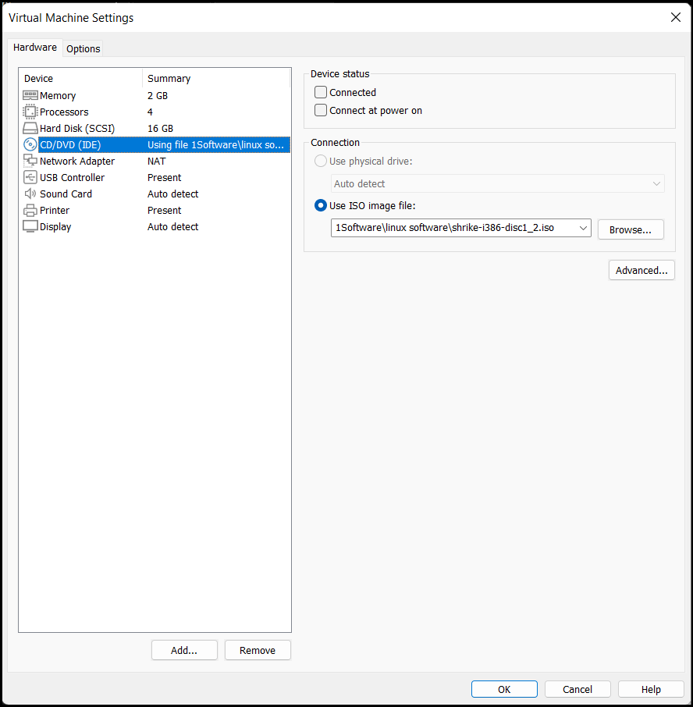Click on ok button.
* Then a dialog box will be open in GUI base.
* Click on No button.
* Select RedHat.
* Select RPM.
* Select any package.
* And copy location/path of package.
* Open new Terminal.
* Type rpm -ivh and paste file path then press enter key.

i for install.

v for verbose.

h for hash.

**If your file name is “foo-1.0-1.i386.rpm. // name(foo), version(1.0), release(1), architecture (i386).**

**i** for installing // rpm -ivh package_name.// rpm -ivh –replacepkgs package_name.

**e** for Uninstalling // rpm -e package_name.

**U** for Upgrading an installed package. // rpm -Uvh package_name

**q** for Querying.

**V** for Verifying.

**F** for upgrade only existing package.

rpm -Fvh package_name. // upgrade only existent packages upgraded.

rpm -Fvh *.rpm //

rpm -q package_name. // display package name, version, and release no.

rpm -qa // show list all installed package.

rpm -q httpd(package_name). // cheking if a package is installed or not.

rpm -ql httpd(package_name).// list all the files for a package.

rpm -Va // verify all installed package throughout the system.

rpm -Vp // if you suspect your databases are currept.

rpm -ivh --replacefiles package_name. // if show error bar, ignore this error.

**rpm -help or man rpm // see about of rpm package uses.**

**Q. How to create Hard link.**

**Process: -**

* Open Linux. And Login root user.
* A hard link is a direct link to the data on disk.
* If original file is deleted then also see your hard link files.
* 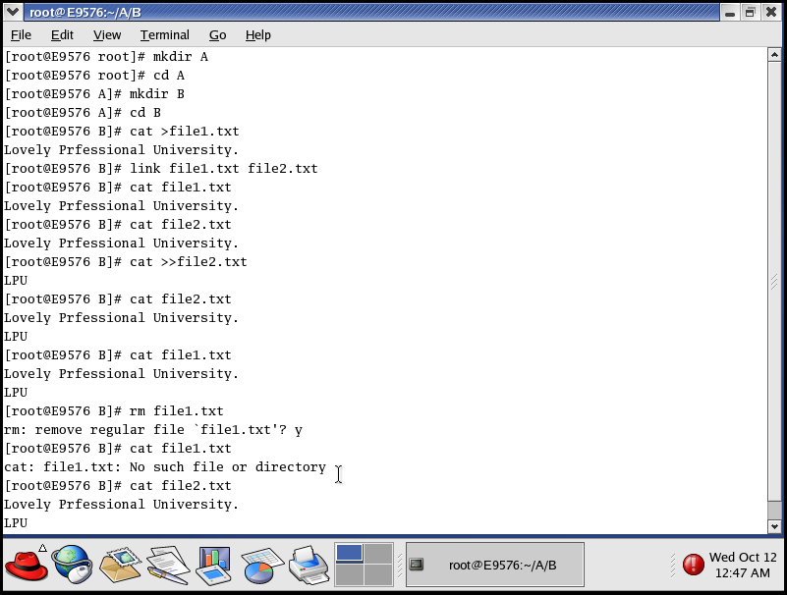Hard link command is only type “link”.

**Q. How to create soft link.**

**Process: -**

* Open Linux. And Login root user.
* A symbolic link does not link directly to the data on disk but to another link to the data on disk.
* If original files is deleted then can’t seen our soft link files.
* 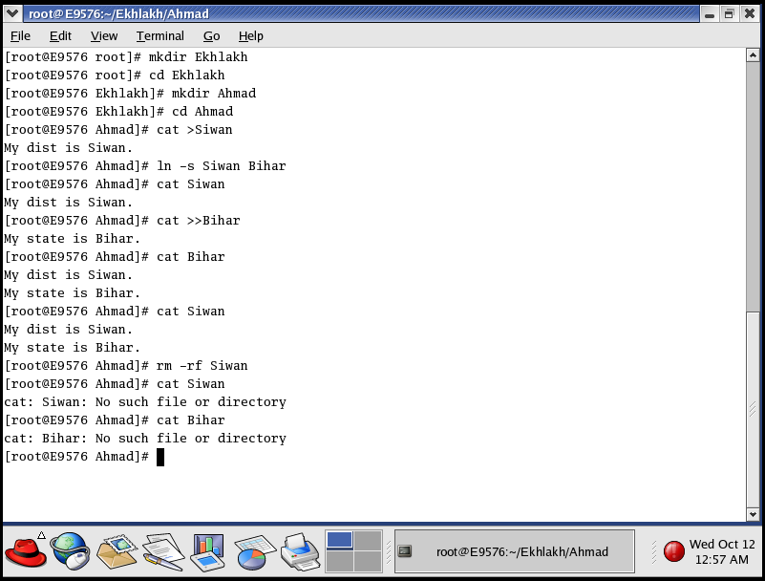Soft link command is type “ln -s”.